 

ASSIGNMENT ON INTERNET TECHNOLOGY(IT)

Assignment Weightage & Type

60% Portfolio Coursework

Corse: BSc (Hons) CS & DF (Sem_2)

NAME: AMAN YADAV

STUDENT ID: 10722

WORLD WIDE WEB

WEEK 2

WORLD WIDE WEB:

World-Wide Web (also called WWW or W3) is a hypertext-based information system. Any word in a hypertext document can be specified as a pointer to a different hypertext document where more information pertaining to that word can be found. Tim Berners-Lee invented the World Wide Web in 1989, after the first connection was established over what is today known as the Interne. By October of 1990, Tim had specified the fundamental technologies that remain the foundation of today’s Web.

HISTORY OF WWW:

Tim also wrote the first Web page editor/browser (“World Wide Web”) and the first Web server (“http”). By the end of 1990, the first Web page was served. V By 1991, people outside of CERN joined the new Web community.

ISP:

An Internet service provider (ISP) is a company that provides web access to businesses and consumers. ISPs may also provide other services such as email services, domain registration, web hosting, and browser services.

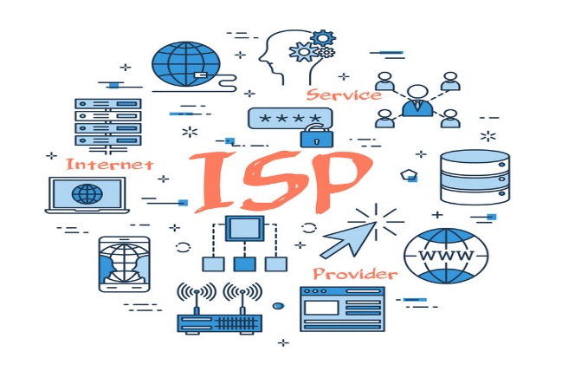

WEBSITE:

website, collection of files and related resources accessible through the World Wide Web and the Internet via a domain name. Organized around a "homepage" (or "landing page"), it is one of the foremost vehicles for mass communication and mass media. A website can consist of one page, or of tens of hundreds of pages, depending on what the site owner is trying to accomplish.

STSATIC AND DYNAMIC WEBSITE:

Static Websites feature fixed content that remains unchanged until manually updated. Content, typically HTML and CSS, is pre-rendered and served to all users consistently. In contrast, Dynamic Websites offer flexible, interactive content generated in real time using server-side scripting and databases.

WEB SERVER:

A web server is a computer system capable of delivering web content to end users over the internet via a web browser.

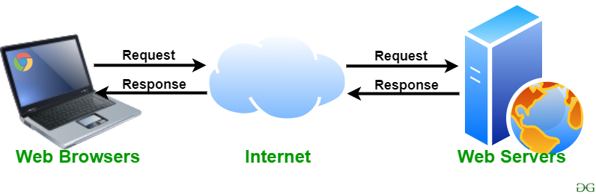

WEB BROWSER:

A browser is an application software used to locate, retrieve and display content on the World Wide Web, including webpages, images, videos and other types of files. Most browsers can be used to access information over the internet as well as local networks or files stored on your computer.



**SEARCH ENGINE**

**SEARCH ENGINE:**

A search engine is a platform on which a user can search the internet content. Google, Yahoo, Bing, Baidu, and DuckDuckGo are popular search engines. Google is one of the most used search engines worldwide that is used with the Chrome browser. So, almost everyone is familiar with it. A search engine is software, usually accessed on the Internet, that searches a database of information according to the user's query. The engine provides a list of results that best match what the user is trying to find.

**HOW TO ACCESS a SEARCH ENGINE:**

For users, a search engine is accessed through a browser on their computer, smartphone, tablet, or another device. Today, most new browsers use an omnibox, which is a text box at the top of the browser. The omnibox allows users to type in a URL or a search query. You can also visit one of the major search engines home page to perform a search.

**HOW SEARCH ENGINE WORKS:**

Because large search engines contain millions and sometimes billions of pages, many search engines not only search the pages but also display the results depending on their importance. This importance is commonly determined by using various algorithms.

#SEARCH ENGINE HAVE THREE PRIMARY FUNCTIONS:

**Crawling**

Crawling is the process by which search engines discover new and updated web pages. This is done using software known as web crawlers or spiders.

### ****Indexing****

After crawling, the information gathered from web pages is processed and stored in an index.

**Rank:**

Provide the pieces of content that will best answer a searcher's query, which means that results are ordered by most relevant to least relevant.

**WHAT IS SEARCH ENGINE CRAWILING?**

Crawling is the discovery process in which search engines send out a team of robots (known as crawlers or spiders) to find new and updated content.

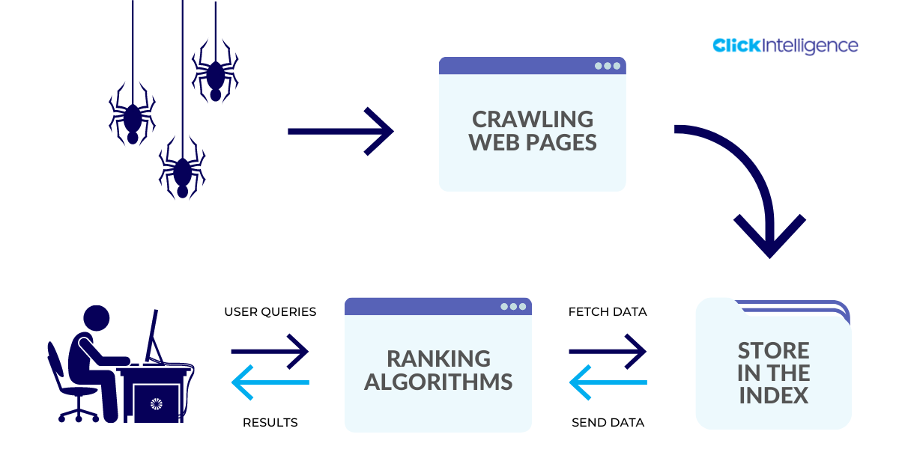

Googlebot starts out by fetching a few web pages, and then follows the links on those webpages to find new URLs. By hopping along this path of links, the crawler is able to find new content and add it to their index called Caffeine — a massive database of discovered URLs — to later be retrieved when a searcher is seeking information that the content on that URL is a good match for.

**WHAT IS SEARCH ENGINE INDEX?**

Search engines process and store information they find in an index, a huge database of all the content they’ve discovered and deem good enough to serve up to searchers.

**SEARCH ENGINE RANKING:**

When someone performs a search, search engines scour their index for highly relevant content and then orders that content in the hopes of solving the searcher's query. This ordering of search results by relevance is known as ranking. In general, you can assume that the higher a website is ranked, the more relevant the search engine believes that site is to the query.

TCP/IP

**TCP:**

Transmission Control Protocol (TCP) is a communications standard that enables application programs and computing devices to exchange messages over a network.

**IP:**

An Internet Protocol (IP) address is the unique identifying number assigned to every device connected to the internet. An IP address definition is a numeric label assigned to devices that use the internet to communicate.

**LAYER OF TCP/IP REFERENCE MODEL:**

There are four layers of the TCP/IP reference model (DARPA model as named by the US Government Agency).They are (network access, internet, transport, and application).

**ISO-OSI SEVEN LAYER MODEL RECALLED:**

The ISO/OSI model is more widely used and accepted but the TCP/IP model is easy to comprehend.

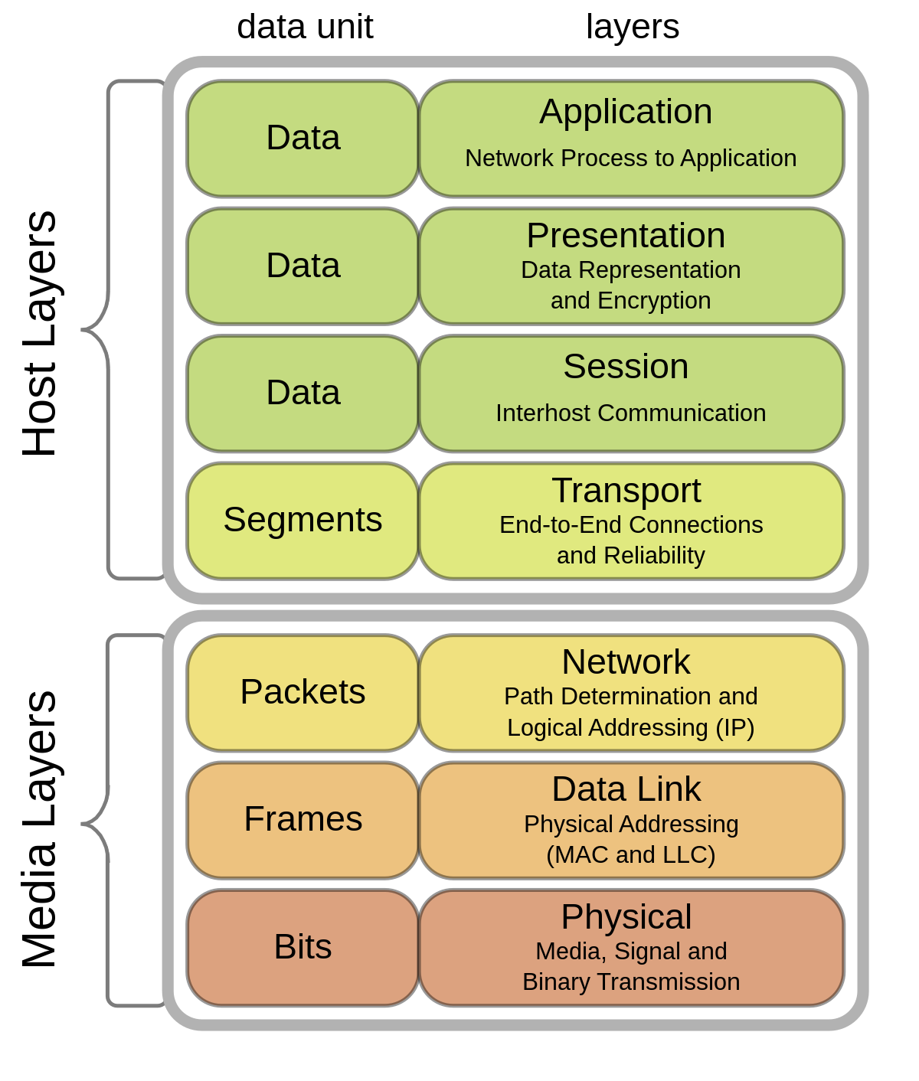

**COMPARISION OF ISO-OSI MODEL AND TCP/IP MODEL:**

Key Difference Between TCP/IP and OSI Model. TCP/IP is a practical model that addresses specific communication challenges and relies on standardized protocols. In contrast, OSI serves as a comprehensive, protocol-independent framework designed to encompass various network communication method.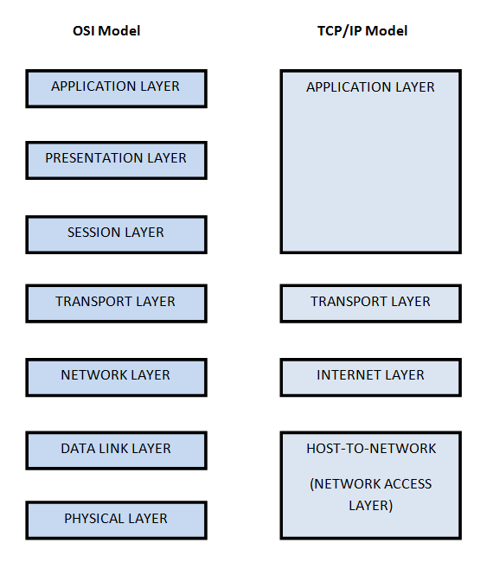

**LAYER REFERENCE TO PROTOCOL:**

Each layer associates one or more protocols with the layer. The layers represent data transfer operations common to all types of data transfers among cooperating networks. The OSI Reference Model lists the protocol layers from the top (layer 7) to the bottom (layer 1).

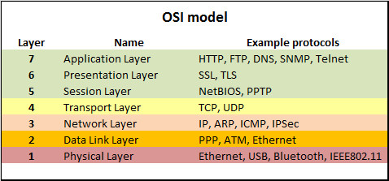

**TCP/IP LAYERS**

1. Network interface layer

2. Internet layer

3. Host-to-host transport layer

4. Application layer

**LAYER PROPERTIES**

In the following slides, the following is described for each layer:

1. Layer function

2. Core protocols

3. Relationship to ISO/OSI model

**NETWORK INTERFACE LAYER:**

The network interface layer provides the control and interface functions for transmitting the IP datagram through the physical layer. To achieve this, it creates an HDLC frame or LAN frame, depending on the physical network structure.

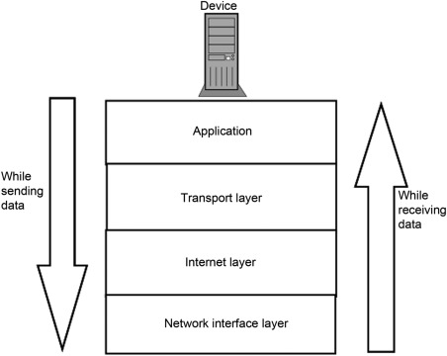

**RELATIONSHIP TO OSI MODEL:**

The OSI Model can be seen as a universal language for computer networking. It is based on the concept of splitting up a communication system into seven abstract layers, each one stacked upon the last. Each layer of the OSI Model handles a specific job and communicates with the layers above and below itself.

**INTERNET LAYER:**

1. Packaging
2. Addressing
3. Routing

**CORE INTERNET LAYER PROTOCOLS:**

The Internet protocol suite is therefore often referred to as TCP/IP. The first major version of IP, Internet Protocol version 4 (IPv4), is the dominant protocol of the Internet. Its successor is Internet Protocol version 6 (IPv6), which has been in increasing deployment on the public Internet since around 2006.

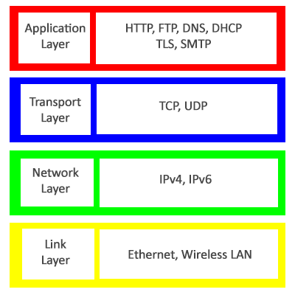

**MORE ON ADDRESS RESOLUTION PROTOCOL(ARP):**

Address Resolution Protocol (ARP) is a protocol or procedure that connects an ever-changing Internet Protocol (IP) address to a fixed physical machine address, also known as a media access control (MAC) address, in a local-area network (LAN).

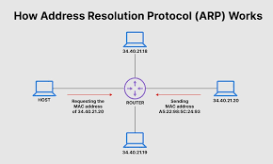

**RELATIONSHIP TO ISO LAYER:**

The ISO-OSI layer model consists of a total of seven layers: the Physical Layer, the Data Link Layer, the Network Layer, the Transport Layer, the Session Layer, the Presentation Layer, and the Application Layer.

**TRANSPORT LAYER:**

The transport layer is Layer 4 of the Open Systems Interconnection (OSI) communications model. It is responsible for ensuring that the data packets arrive accurately and reliably between sender and receiver. The transport layer most often uses TCP or User Datagram Protocol (UDP).

**CORE PROTOCOLS OF THE TRANSPORT LAYER:**

Transport layer protocols, namely, Transmission Control Protocol (TCP) and User Datagram Protocol (UDP), identify applications communicating with each other by means of port numbers.

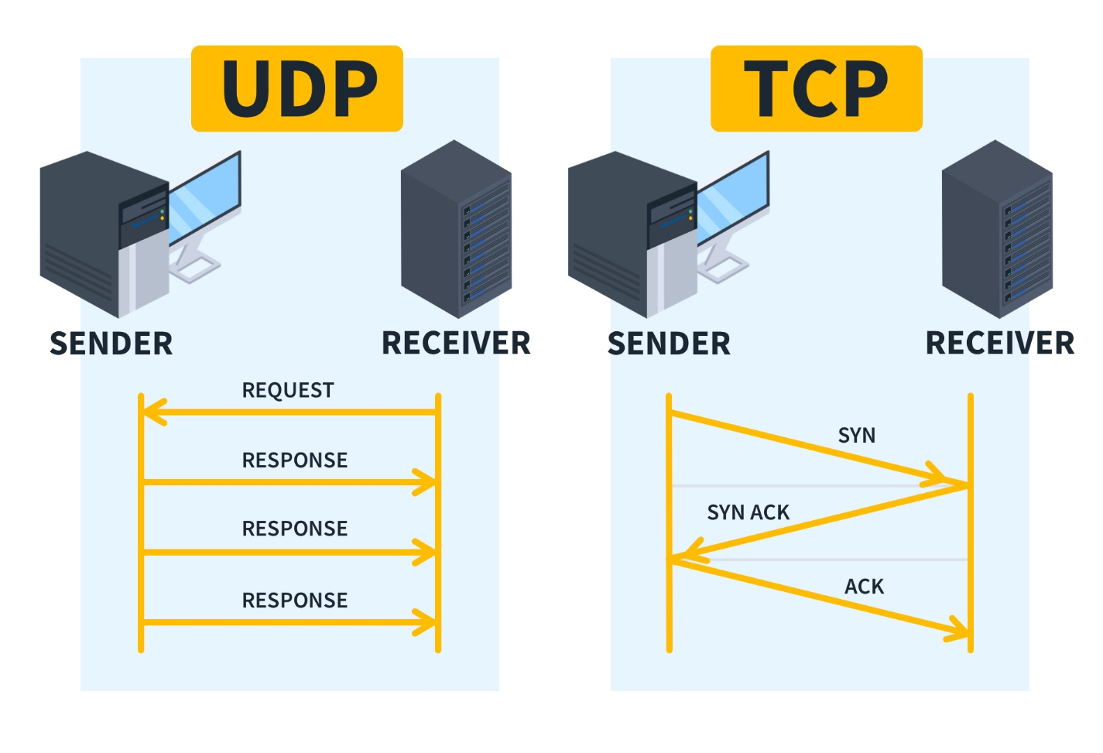

**APPLICATION LAYER:**

Transport layer protocols, namely, Transmission Control Protocol (TCP) and User Datagram Protocol (UDP), identify applications communicating with each other by means of port numbers.

**SOME CORE PROTOCOLS:**

1.HTTP

2. FTP

3. Telnet

4. SMTP

5. POP3

6. IMAP

7. SNMP(Simple Network Management Protocol) etc.

**TCP/IP INTERNET LAYER:**

1.An Internet is an interconnection of two or more networks

2.Internet layer handles tasks similar to network access layer, but between networks rather than between nodes on a network

3.Uses IP for addressing and routing across networks Implemented in workstations and routers.

**TCP/IP APPLICATION LAYER:**

1. Logic needed to support variety of applications
2. Separate module supports each type of application (e.g. file transfer)
3. FTP
4. HTTP
5. Telnet
6. News
7. SMTP

**WEB HOSTING**

**WEB HOSTING:**

When a hosting provider allocates space on a web server for a website to store its files, they are hosting a website. Web hosting makes the files that comprise a website (code, images, etc.) available for viewing online. Every website you've ever visited is hosted on a server.

**WEB HOSTING IS A SERVICE MAINLY FOR THE PURPOSE OF:**

* Registering a domain name
* Building a website
* DNS
* E-mail service
* Customer support

**ARE DOMAIN AND WEB HOSTING THE SAME?**

Domain and hosting are two different things but equally important to build a website. A domain name is a website's digital identity that allows internet users to access your website easily. Whereas, web hosting stores your website's data. A domain name generally needs a website name and a domain extension like .com, .

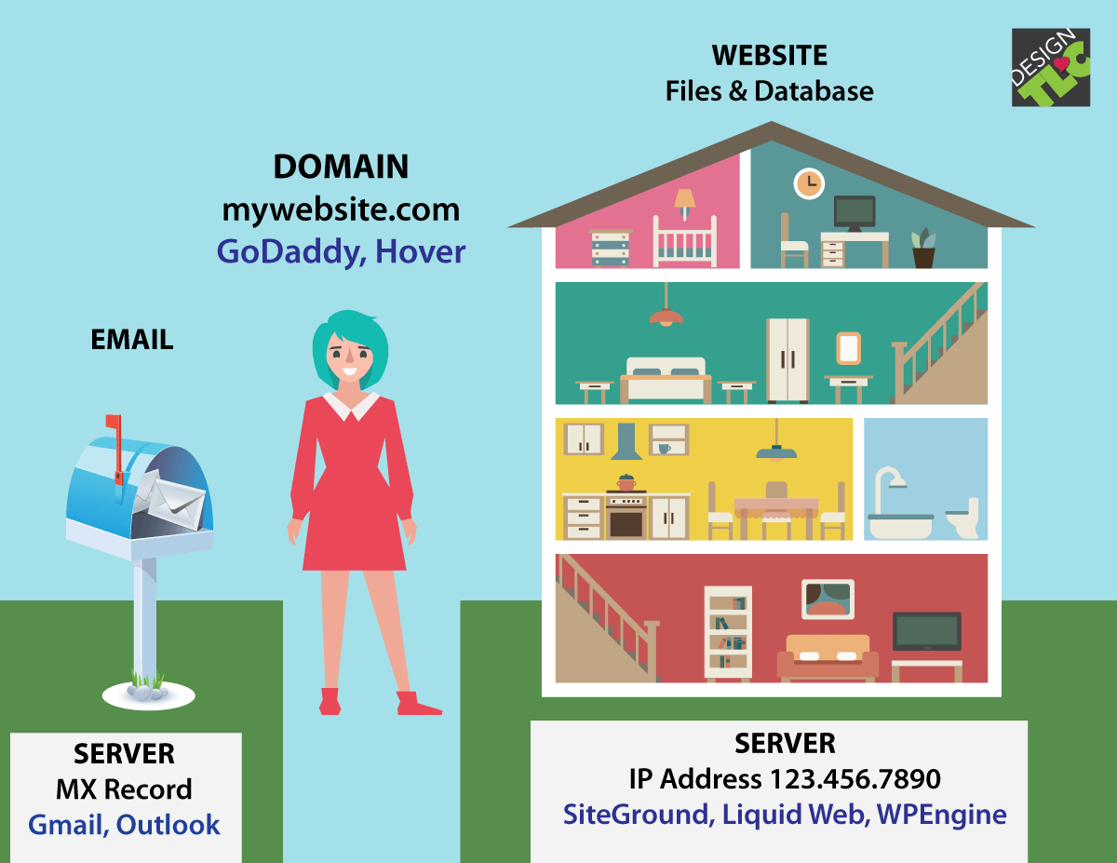

**GETTING A DOMAIN NAME:**

Once you decide for a name of your website, or a domain name for your email addresses to use, you need to ‘register’ that domain name with a company licensed to register domains. These kinds of companies are called ‘Registrars’.

**GETTING HOSTING FOR THE DOMAIN NAME:**

After you register a domain, you can now buy a web hosting plan from a hosting company like Hostway and can then put you website(house) and email to ‘live’ at the hosting company (land).

**HOW DO THE DOMAIN NAME AND HOSTING CONNECT?**

1. Access your Domain Registrar Account.
2. Find DNS Management or Name Server Settings.
3. Find the Name Server Settings.
4. Update the Name Servers to Your Hosting Provider's Name Servers.
5. Update Your Name Servers.
6. Click Save and you're done.
7. Verify the Connection.

**DOMAIN NAME REGISTRATION:**

1. Choose a domain name.
2. Check for domain availability.
3. Choose a domain name registrar.
4. Purchase and register.
5. Renew your domain name.

**DNS – DOMAIN NAME SYSTEM:**

The Domain Name System (DNS) turns domain names into IP addresses, which browsers use to load internet pages. Every device connected to the internet has its own IP address, which is used by other devices to locate the device.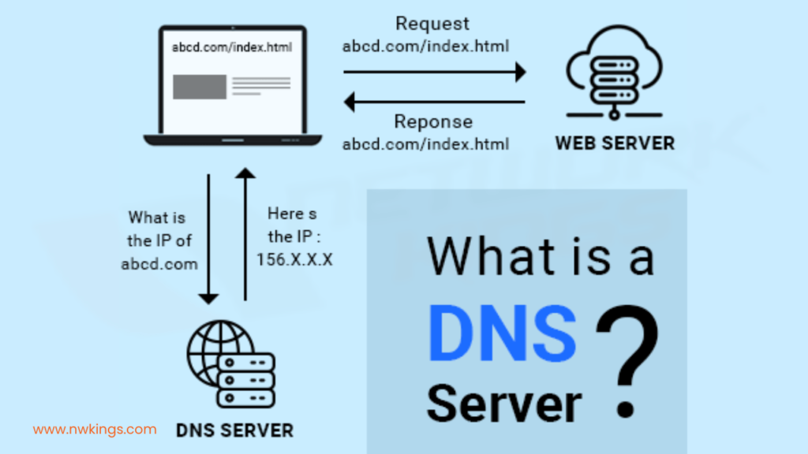

**WEB HOSTING:**

When a hosting provider allocates space on a web server for a website to store its files, they are hosting a website. Web hosting makes the files that comprise a website (code, images, etc.) available for viewing online. Every website you've ever visited is hosted on a server.

**SITE CONTROL:**

The term “site control” is widely used in the development community, and simply means some form of right to acquire or lease the site. The type of site control that can be achieved depends on many factors, including the owner's interests, the timing and stage of financing commitments, and any lenders' requirements.

**WEB HOST MANAGER(WHM):**

WHM (Web Host Manager) provides administrative control over your dedicated server or VPS. It allows a hosting provider to manage a customer's account. WHM is also a reseller control panel.

**C PANEL:**

Control panel is the administration web interface of your webhosting account. It is an interface that you access to administer all the aspects of your account. You can typically control all portions of your site within the control panel without using any additional software like FTP software to upload files, though many people find it faster and easier to do so.